R-L and R-C DC Transient

Name: Adwait S Purao

UID: 2021300101

Batch: B2

**Question 1:**

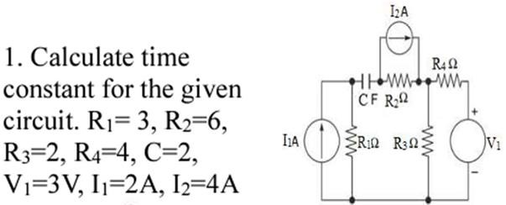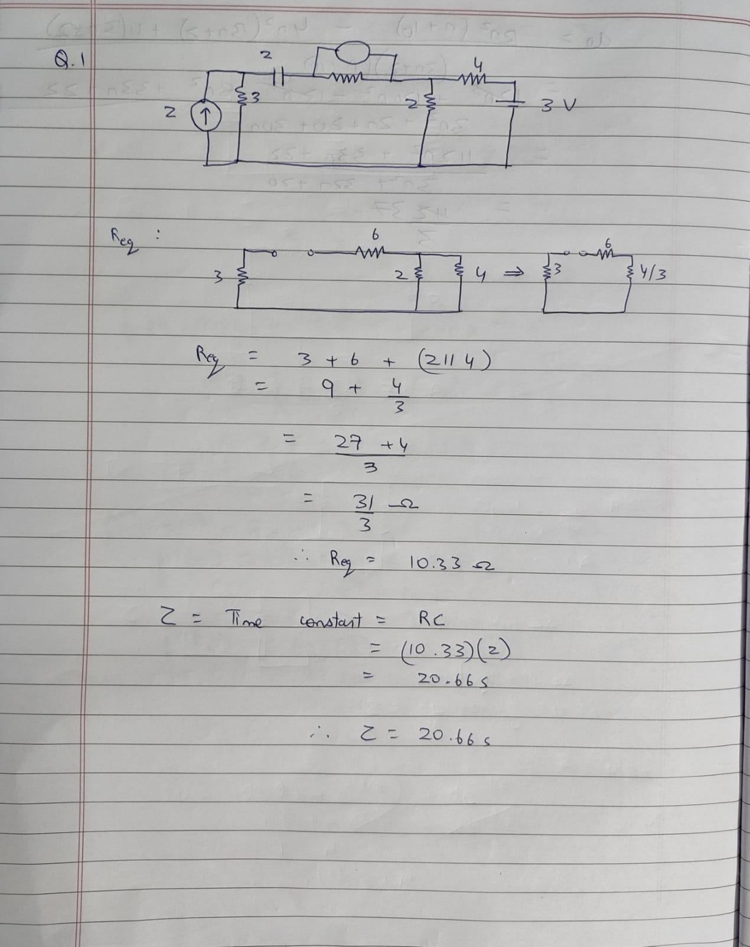

**Sequel Solution:**

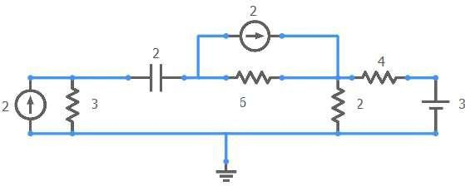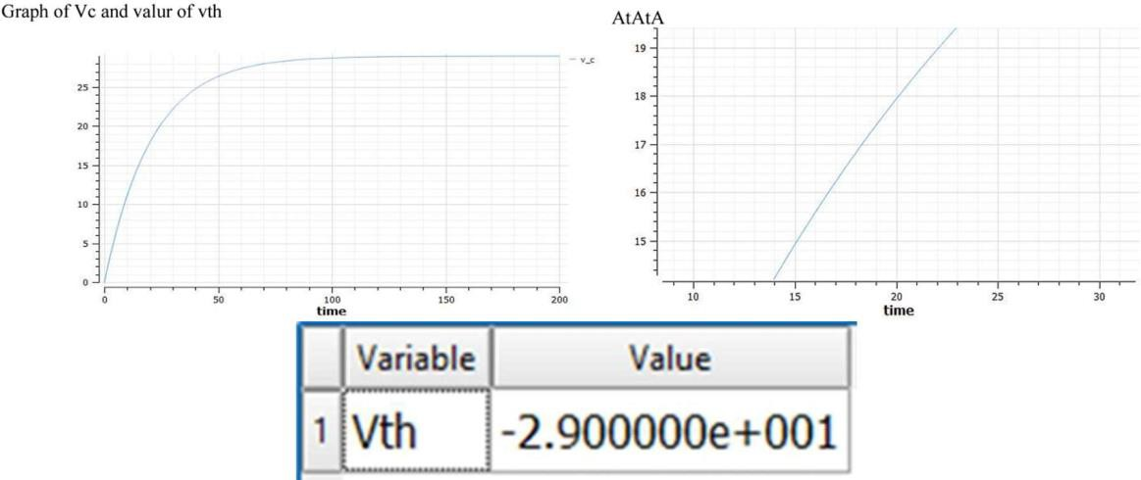

At 63% of voltage reached the time is 20 sec which matches the theoretical value of Time constant. Also the value of VTh matches the peak voltage.

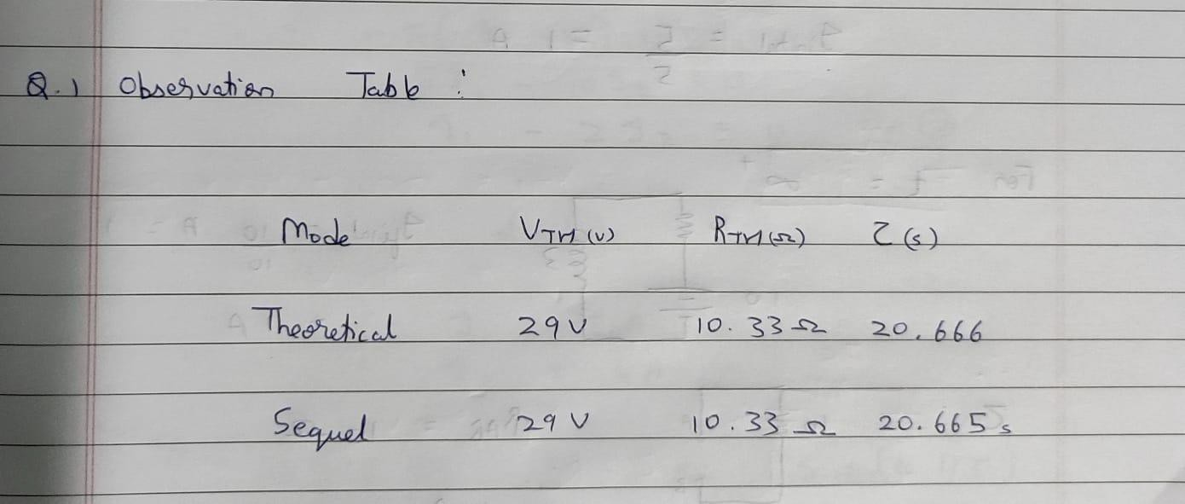

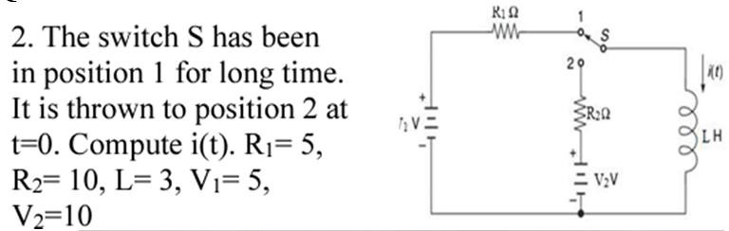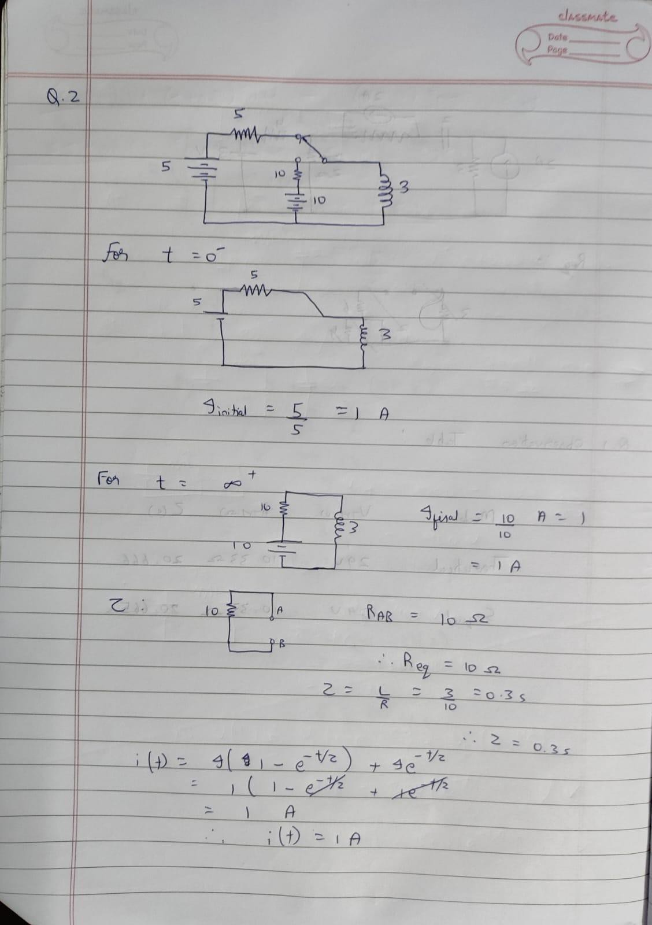**Question 2:**

**Sequel Solution:**

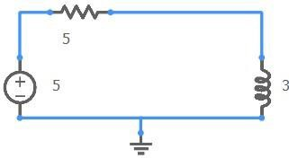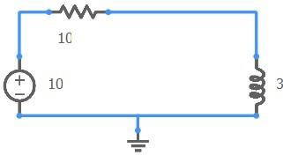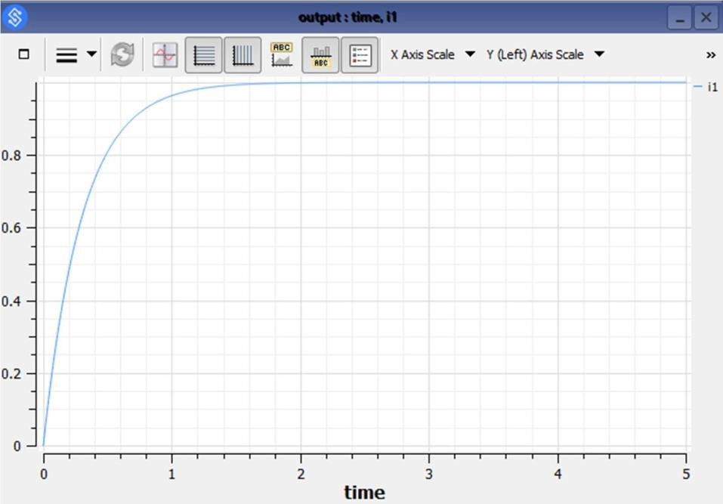

**Question 3:**

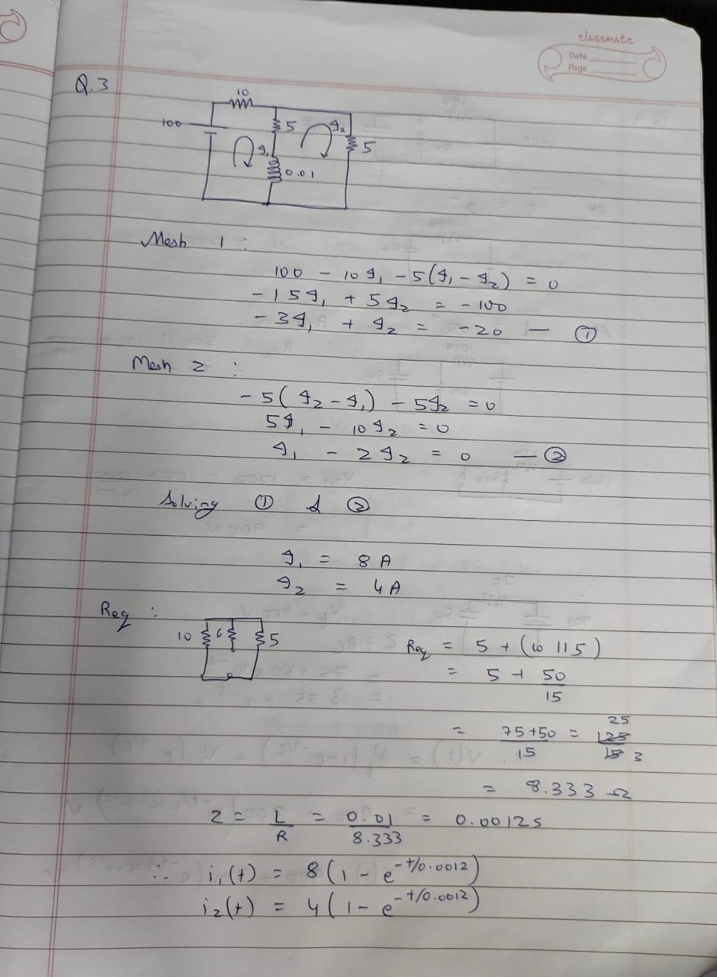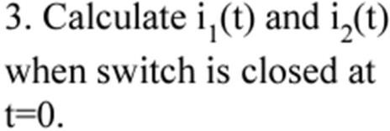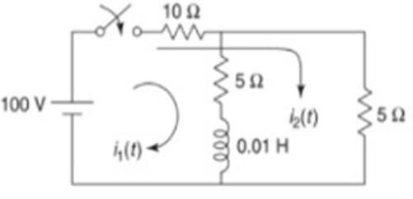

**Sequel Solution:**

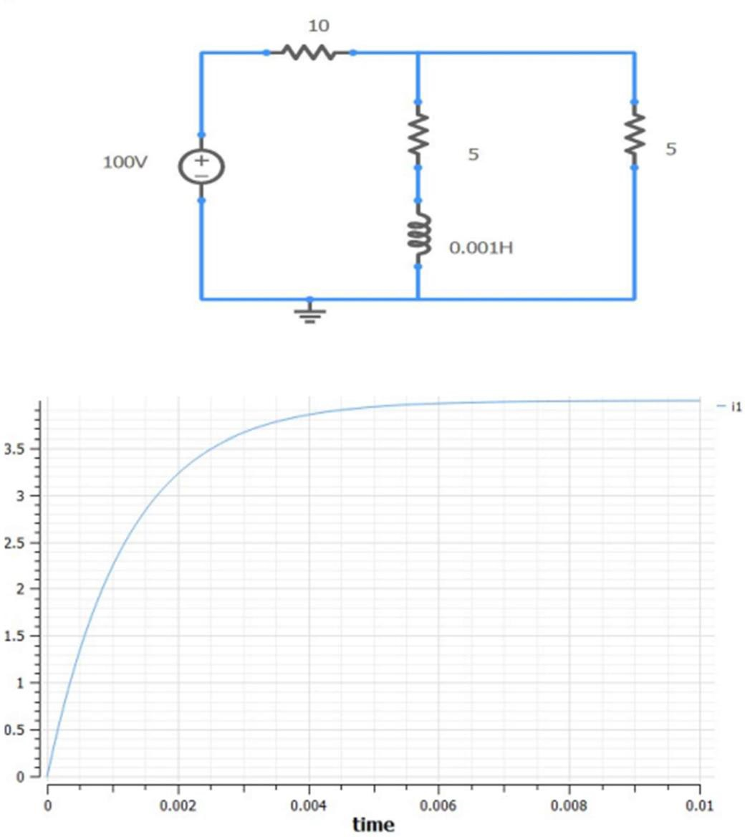

The peak value of current of both, the theoretical and sequel implemented circuits come out to be 4A

**Question 4:**

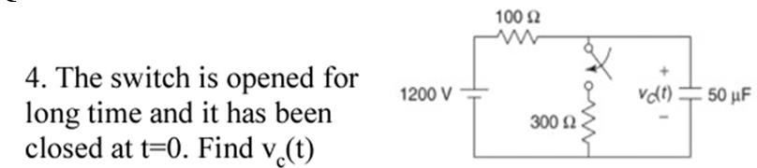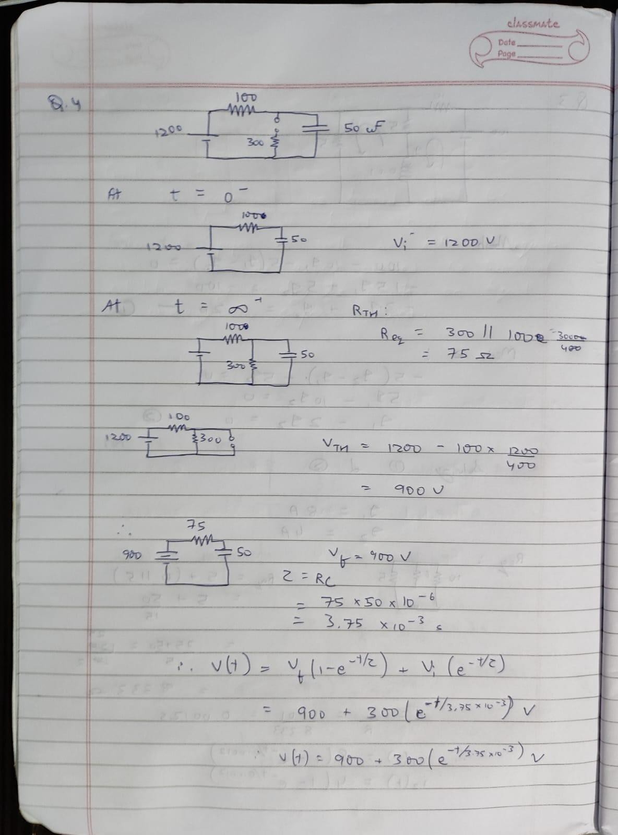

**Sequel Solution:**

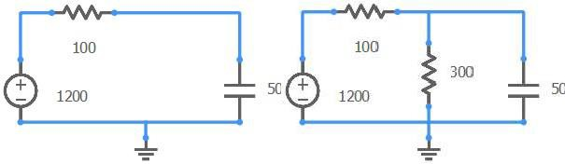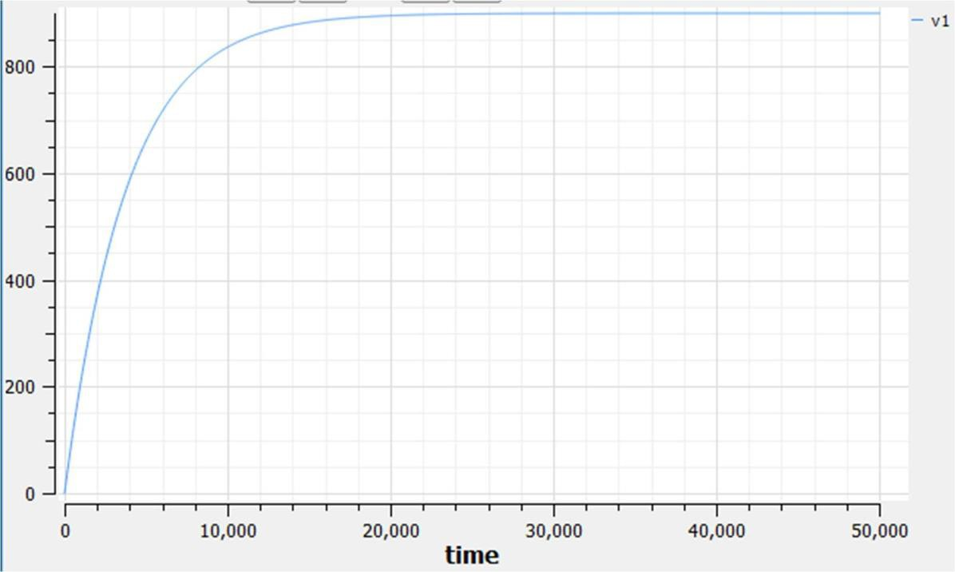

The final value of voltages both, the theoretical and sequel simulation comes to 900V.

**Question 5:**

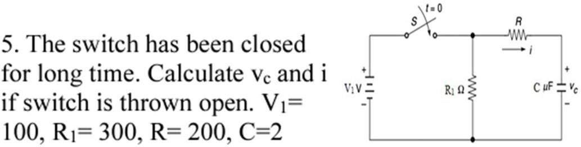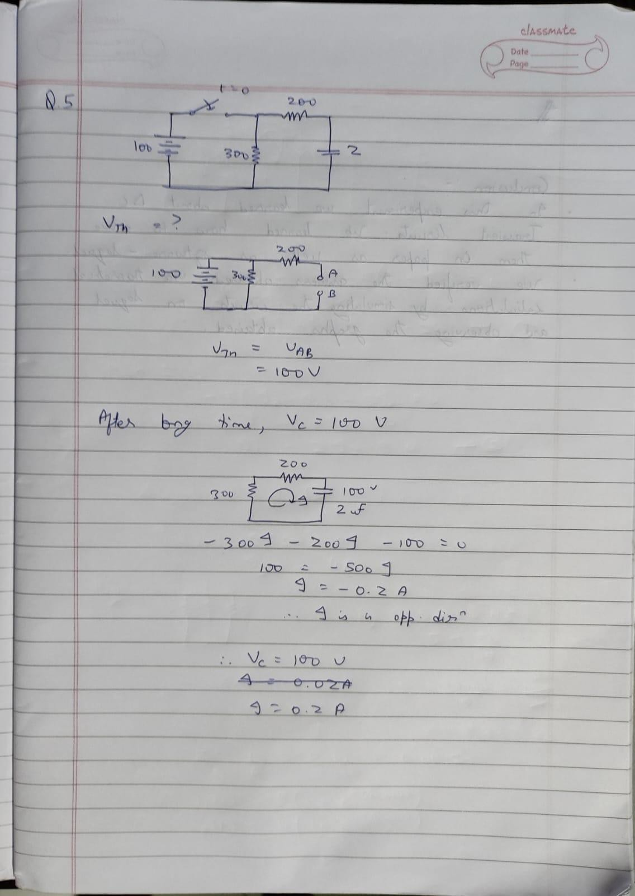

**Sequel Simulation:**

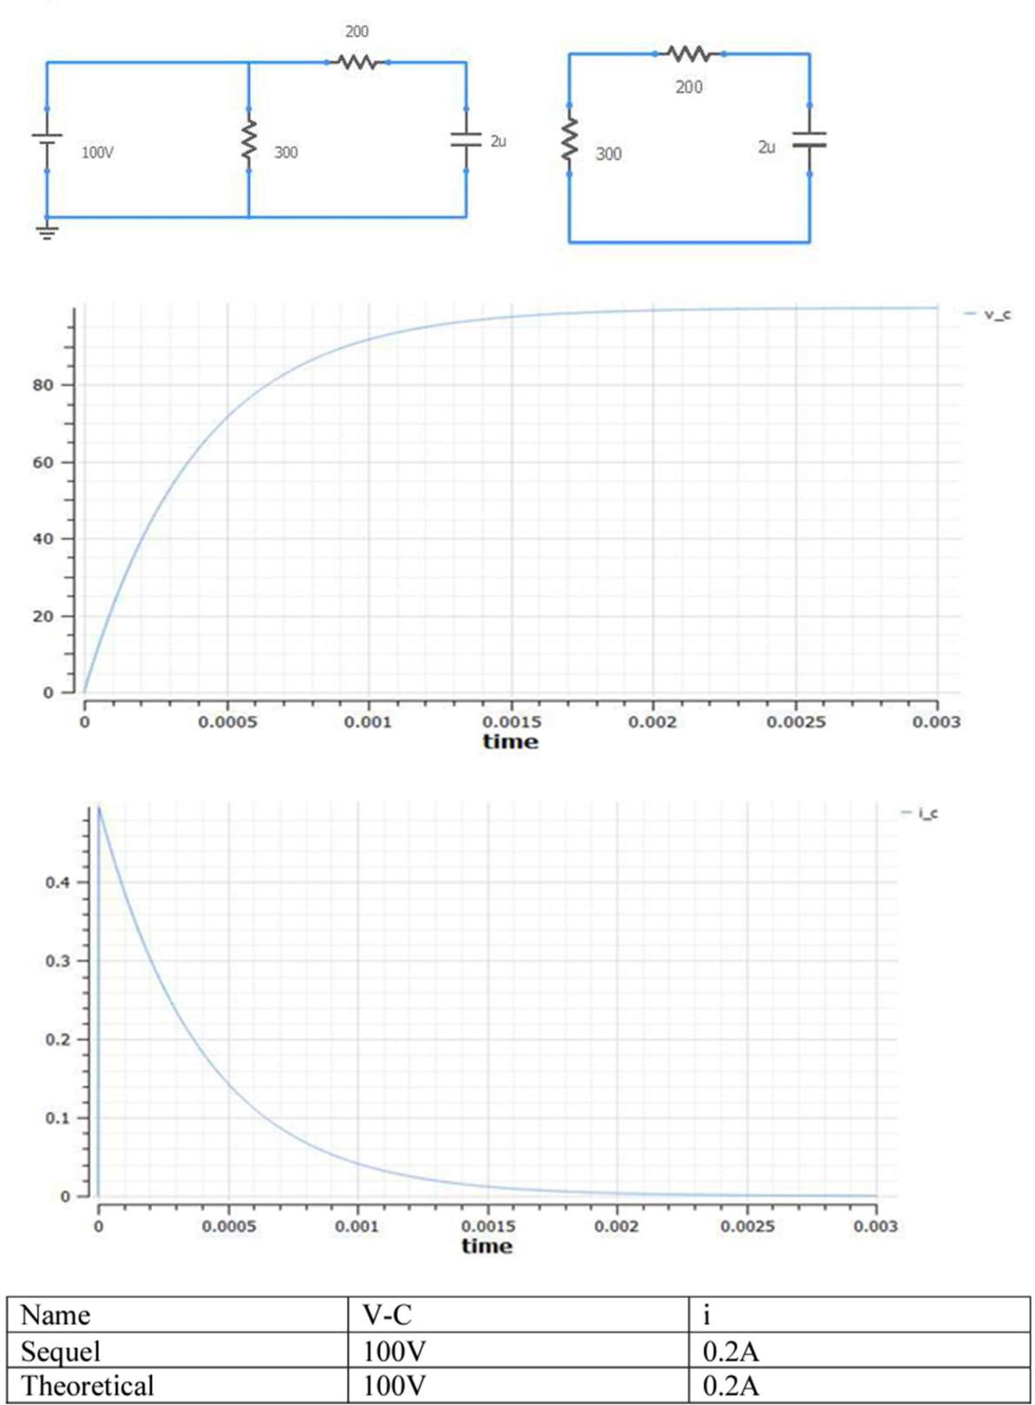

# EXPERIMENT No: 4 DATE: 10 / 07 / 2022

**R-L and R-C DC Transient response**

**AIM:** To verify DC Transient response for the given R-L an R-C circuits.

**APPARATUS AND COMPONENTS REQIRED:** Sequel Simulator

# THEORY: Write theory related with following questions:

1. Define time constant, initial condition, final condition, transient response, natural response, forced response.

**Time Response:** The time required for a changing quantity in a circuit, as voltage or current, to rise or fall approximately 0.632 of the difference between its old and new value after an impulse has been applied that induces such a change: equal in seconds to the inductance of the circuit in henries divided by its resistance in ohms.

**Initial Condition:** The values of the dependent variable (current and voltage) and their higher derivatives just after the instant of switching are known as an initial conditions.

**Final Condition:** The values of the dependent variable (current and voltage) and their higher derivatives at a very long time after the instant of switching are known as an final conditions.

**Transient Conditions:** a transient response or natural response is the response of a system to a change from equilibrium

**Natural Response:** The natural response of a circuit is what it does “naturally” as its internal energy moves around. As the energy sloshes around we track what happens to voltage and current.

**Forced Response:** The forced response is where the output (the voltage on the capacitor) is going to end up in the long run after all stored energy eventually dissipates.

# PROCEDURE:

1. Solve the problems given in below table (as per your batch e.g. X1= A1/B1/C1) to obtain transient response of R-L and R-C circuits
2. Verify the solution of the problems solved in step 1 using Sequel software.

# RESULT:

|  |  |  |  |
| --- | --- | --- | --- |
| **Problem no.** | **Parameter** | **Theoretical** | **Practical** |
| **1** | Time Constant | 20.667 s | 20.665 s |
| **2** | Current | 1 A | 1 A |
| **3** | Current | 4 A | 4 A |
| **4** | Voltage | 900 V | 900 V |
| **5** | Voltage and Current | 100 V, 0.2 A | 100 V, 0.2 A |

**CONCLUSION:**

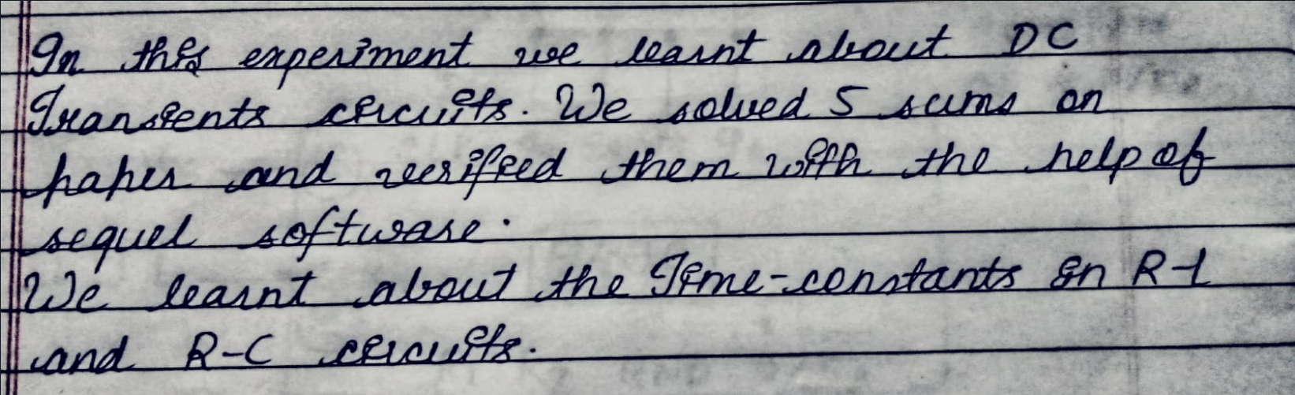as

**Bharatiya Vidya Bhavan’s**

**Sardar Patel Institute of Technology**

Bhavan’s Campus, Munshi Nagar, Andheri (West), Mumbai-400058-India (Autonomous College Affiliated to University of Mumbai)

**Applied Science and Humanities Department**